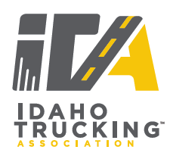
Truck Driving Championships
Instructions for Whistle and Horn Use

- One long whistle means STOP. Two short whistles means GO.

- A Judge or Timekeeper will blow one long whistle (STOP) if the Contestant is causing damage to the equipment being driven. The Contestant will be held stationary and the Course Marshall will be summoned.

- In the event that a Contestant is required to leave a problem for any reason the appropriate official will give one long whistle (STOP), followed immediately by two short whistles (GO) to tell the Contestant that he/she must leave the problem. Judges should be prepared, if necessary, to tell the Contestant to leave.

- The Contestant will give one long blast on the horn (STOP) if he/she is having difficulties with the vehicle such as engine not running properly, inability to shift gears, mechanical defects, etc. The Timekeeper will STOP the time on the Contestant until such time the problem is resolved.

- When a Contestant must stop at a problem to be measured for a score, the Contestant will blow two short horn blasts (GO) to indicate readiness for measurement. Failure to do so will result in a 5 point penalty for no horn. When the measurement is complete, the Judge will blow two short whistles (GO) to notify the Contestant he/she is free to leave.

