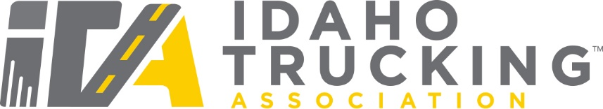

IDAHO MAINTENANCE PERSON OF THE YEAR AWARD

Sponsored by Hub International
Administered by the Safety Awards Selection Committee
Idaho Trucking Association
3405 East Overland Road/ Suite 175, Meridian, ID 83642

RULES:
- The contest year is January 1, 2022, through December 31, 2022.
- The contest is open to companies of all sizes including small owner/operators. The maintenance person must be employed by a member company of the Idaho Trucking Association.
- Any member company may submit only one maintenance person per contest year. The candidate must have been employed by their current employer for the entire contest year.
- The nominee for “Maintenance Person of the Year” must be actively involved in the preventive, scheduled or non-scheduled maintenance of a ‘for-hire’ or a ‘private carrier’ truck fleet. This will include Directors of Maintenance, Technicians, or other persons responsible for those duties.
- The Safety Awards Selection Committee will particularly consider the candidate’s performance during the contest year; however, performance over prior years is also important in the selection process.
- The maintenance person will be ineligible for this award if he/she has won within the last three contest years.
- The Safety Awards Selection Committee will use officially approved and established criteria to select the winner of the award.
- Submissions are limited to this official entry form and must be legible.
- Although this form is fillable, we will require handwritten signatures.
- Submission deadline is: To Be Determined.

Mail to:
ITA Safety Awards Selection Committee
3405 East Overland Road/Suite 175
Meridian, ID 83642
Fax to: 208.343.8397
E-mail to: office@idtrucking.org

CERTIFICATION AND AGREEMENT

As a nominee for the “Idaho Maintenance Person of the Year” program, and to be eligible for the award offered to the winner, I hereby certify:

- All of the statements contained in the material in support of my nomination for the “Idaho Maintenance Person of the Year” award are true.
- I will conduct myself in such a way as to protect and maintain the high status of the title “Idaho Maintenance Person of the Year” and I agree that the title may not be used in any advertising, promotion or exhibiting except those sanctioned in writing by the ITA Safety Awards Selection Committee.

___________________________________________________ ______________
Nominee’s Signature Date

As a company official, I certify:
- All statements contained in, and the material submitted herewith for this Idaho Maintenance Person of the Year nomination have been investigated and reviewed by representatives of this company, and are submitted in accordance with the rules set forth for the ITA/SMC “Idaho Maintenance Person of the Year” program.

_____________________________________________________________________________

Signature of Company Officer

Print Name: Click or tap here to enter text. Date Click or tap here to enter text.

Reviewed by: (ITA Office use only)

____________________________________________________________________________
Signature Date

IDAHO MAINTENANCE PERSON OF THE YEAR AWARD CANDIDATE INFORMATION

Name: Click or tap here to enter text.
Home Address: Click or tap here to enter text.
Present Employer: Click or tap here to enter text.
Employer Address: Click or tap here to enter text.
Your Current Terminal Address: Click or tap here to enter text.
Past Employer: Click or tap here to enter text.
Total years employed in the maintenance field: Click or tap here to enter text.
Other Previous Employers: (list dates and locations) Click or tap here to enter text.

Lists the types of equipment responsible for and/or shop duties: Click or tap here to enter text.
List the characteristics and accomplishments which lead you consider nomination for this award: Click or tap here to enter text.

Certificates/Awards/Recognitions: Click or tap here to enter text.

Please circle preferred shirt size:
☐XS ☐S ☐M ☐L ☐XL ☐XXL ☐XXXL ☐XXXXL

Military Record:
Branch of Service: Click or tap here to enter text.
Dates: Click or tap here to enter text.
Principal Duties: Click or tap here to enter text.
Campaigns and Citations: Click or tap here to enter text.

Memberships to Lodges, Clubs, Associations or Organizations:Click or tap here to enter text.

Volunteer experience and/or community involvement/hobbies or other activities:
Click or tap here to enter text.

If you have any questions regarding the application, please call Idaho Trucking Association at 208.342.3521 or e-mail office@idtrucking.org.
Submit this Nomination to: office@idtrucking.org

THANK YOU FOR YOUR NOMINATION, WE WISH YOU THE BEST OF LUCK!

